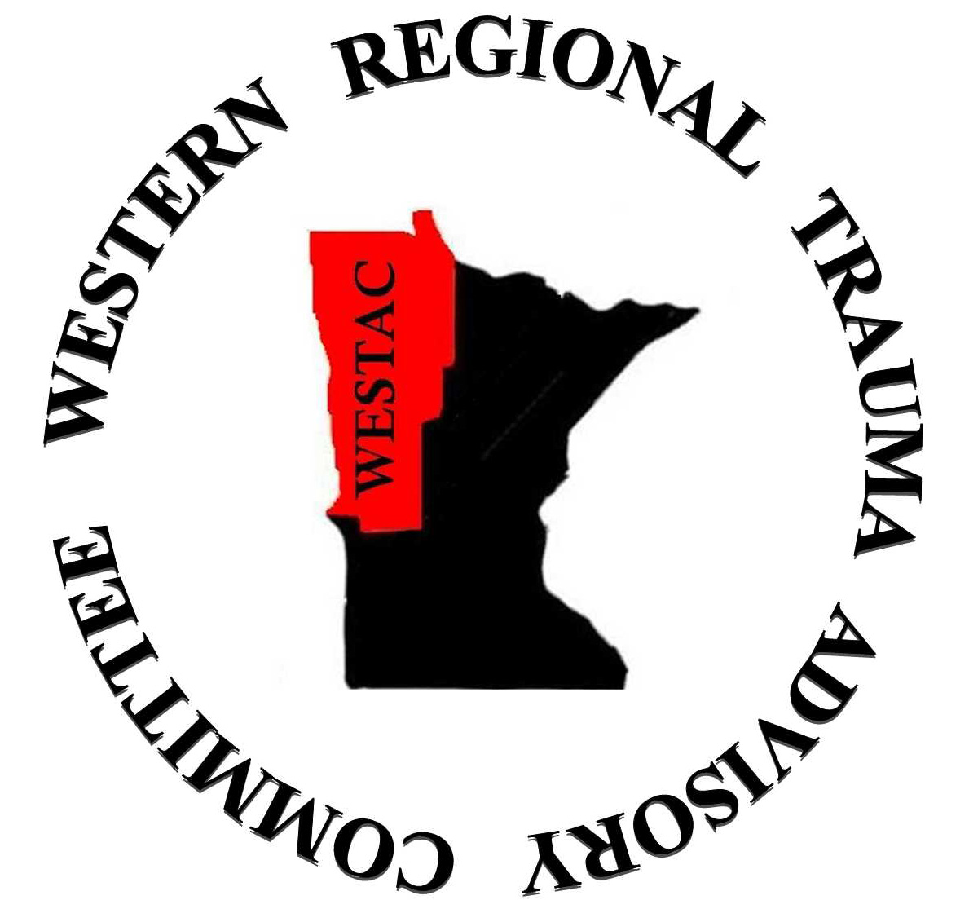

WESTAC Meeting Minutes
December 11, 2014
Essentia St. Mary’s, Detroit Lakes

TOPIC | DISCUSSION/RECOMMENDATIONS | ACTIONS/FOLLOW-UP  (Include Responsible Party and Timeline)
- Welcome and Introductions | - All attendees were welcomed. Attendees include: Tom Alinder, Joseph Beaudreau, Vicky Black (Secretary), Mari Elliott, April Grunhard, LynMaree Harris, Doug Harthon, Michael Harvey, Brenda Huwe, Heather Lundeby, Stacy Monkman, Ralph Morris (Vice Chair), Deb Syverson (Chair), Tom Vanderwal (Treasurer), Jeremy Vogt, Khaled Zreik.  - The September 2014 meeting minutes were approved as written.  - Current committee membership was reviewed. Open positions for the RTAC leadership were reviewed and nominations for the open positions were made. See following list.  - Vicky Black’s hospital affiliation should be corrected to Essentia Health.  - One Level III position is open and Dr. Randy Bowlar was suggested to fill that position.  - One of the four Level IV positions will be filled by Stacy Monkman from Lifecare Medical Center in Roseau. Brenda Smith Morris was suggested to fill the other position left open when Lynn Siegel vacated the position.  - Todd Gladner was suggested for the Consumer/Elected position.  - Karen Mosher was suggested to fill the open Public Health position.  - Dr. Zreik will fill the Trauma Surgeon position.  - It will need to be confirmed that Bud Belk is still willing to serve as the Emergency Medicine Physician representative.  - Applications for appointment for the RTAC leadership members present were distributed and signed. | - Dr. Morris will make the appropriate changes to the formal committee membership roster for submission to the STAC.  - Dr. Morris will ensure that persons nominated for positions on the RTAC are contacted and agreeable to serving in the WESTAC.
- MN State Trauma System | - RTAC Leadership Meeting Report. The meeting was held 12/9. The regional committee in the SMARTAC is looking at regional QI issues, including LOS at the smaller referral facilities and the use of air transport. They are also reviewing the current status of the trauma registry and possible future directions for the state registry. Information was handed out to the group listing some of the items that were discussed. Based on these discussions the state will be calling together a data subcommittee to focus on making the registry more usable and the data more valid. In addition, there will be additional registry training held to try and ensure that the data being entered into the registry is more reliable. The Department of Health continues to try and integrate the MN STAR data into the trauma registry in order to create a more complete picture for the trauma registry, and work also continues with CDM to create an export into the Image Trend registry. The SMARTAC is also in the process of developing a TPM manual.  - STAC. The Department of Health is working with the State Advocacy Funding Consortium on the trauma readiness bill. This coalition works on many funding requests from across the state and allows for a larger pool of funding from the insurance initiatives and fees to be accessed. The MN Hospital Association is the lead agency for this group. The MDH will be providing TPM training in Bemidji in April, with trauma registry training to be held in conjunction with that meeting. These meetings will be held again in Mankato in September. Additional details are TBA. The state is also looking to hire a second designation coordinator in the hopes of catching up on the site visits and site visit reports that are outstanding. There are also many open positions on the STAC. Additional information on all open positions and the requirements for each position are available on the state’s website. Lastly new criteria for Level III centers are being developed, and additional details will be available in the future.  - Future meeting dates: 3-3-15, 6-2-15, 9-15-15, and 12-8-15.  - WESTAC hospital designations | The WESTAC may look at hosting these two training events in the future as part of the grant deliverables
- Financials | - The current report was distributed. The current available balance is $9,185.47. Last year’s grant amount of $5400 has been received from the Office of Rural Health, however that is not reflected on the report.  - The grant contract for this fiscal year has been signed and is valid through 8/31/15 for the amount of $6200. The grant deliverables will include further distribution and education based on the regional trauma manual, meeting expenses, and some reimbursement for travel. | Deb and Dr. Morris will continue work on the grant deliverables.
- Toward Zero Deaths and Other Injury Prevention Activities | - The TZD coordinator was unable to attend.  - Tom Vanderwall did attend the TZD conference. There were roughly 1000 attendees. There was a speaker from FM Ambulance who presented on the topic of triage, and it was well received. Tom noted that he hopes we can bring a similar conference to this region.  - Sanford Bemidji noted that they providing helmets for snowboarding.  - Essentia Health St. Mary’s noted that they are developing a program for ice house safety.  - Alexandria is developing a distracted and inattentive driving program.
- EMS / Hospital / ED Responsibilities During an MCI | Tom Alinder shared that the last regional disaster drill in 2012 went very well. Planning has begun for another regional disaster exercise. He noted that it was identified at the last exercise that the transport officer role needs to be better defined.
- Performance Improvement | A Pediatric Radiation Exposure Guideline has been developed for the WESTAC. It has been included in the regional treatment guidelines manual.
- RTTDC (Rural Trauma Team Development Course) | Deb is going to try and include this course as one of our grant deliverables. This is a case study based course that is brought out to the smaller more rural facilities. The MN COT has already been contacted and they may be able to assist with funding the course.
- WESTAC Trauma Treatment Guidelines Manual Update | The manual is in the process of being revised and updated. Deb has been contacted by the state coordinator in SD and it is being reviewed for use there also.
- Regional priorities and concerns | - Non –designated hospitals (Baudette, Cass Lake, Hallock, Red Lake and Warren). Baudette has a new DON and TC and they are beginning to work toward designation. Their biggest concern at this time is the ATLS certification for their providers. In Hallock there is more support for becoming designated, but there has been no additional activity toward designation. The Cass Lake hospital still does not have a representative to this group, and has not moved toward designation; however there is now a representative from the Cass Lake EMS service in attendance at the WESTAC meetings.  - Education needs. Let Deb know if there are any requests or suggestions for education.
- Upcoming regional events | - Trauma Tactics, Sunday, February 8, Holiday Inn, Fargo.  - Statewide Trauma Program Manager Training, April 9, Bemidji.  - Statewide Trauma Registrar Training, April 10, Bemidji.  - Statewide TPM and Registrar Training, being planned for September in Mankato.  - April 22, RTAC Leadership Meeting, additional details TBA.
- Other | No discussion.
- Meeting adjourned | - The meeting was adjourned at 12:30.  - The next meeting will be held March 12th at Essentia Health St. Mary’s in Detroit Lakes. Additional information to come.  - Future WESTAC dates: 3/12/15; 6/11/15, 9/17/15, 12/10/15.

Vicky Black, Recorder

