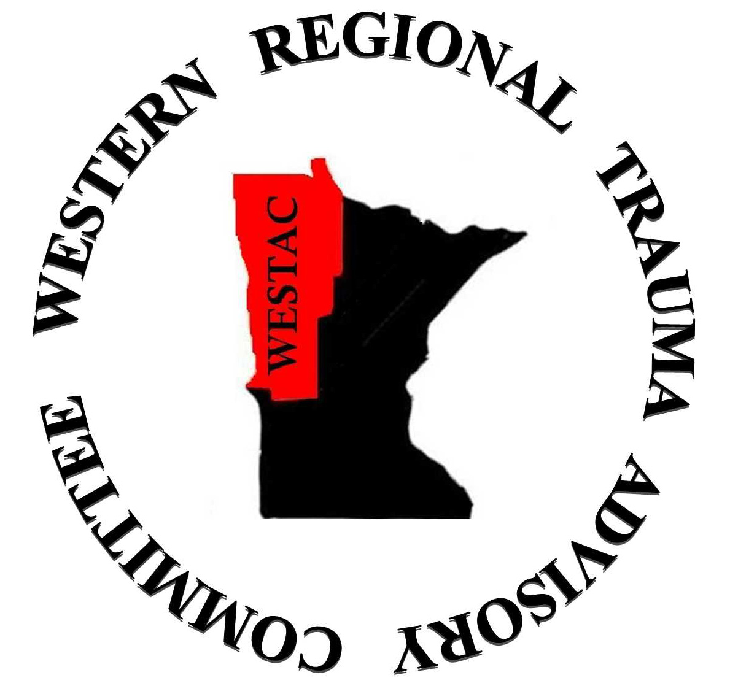

WESTAC Meeting Minutes
September 11, 2014
Essentia St. Mary’s, Detroit Lakes

TOPIC | DISCUSSION/RECOMMENDATIONS | ACTIONS/FOLLOW-UP  (Include Responsible Party and Timeline)
- Welcome and introductions | - Moment of silence observed in honor of September 11, 2001.  - Attendees: Tom Vanderwal, Heather (LF), Vicky Black, ralph Morris, Leigh Laroque, NM Bemidji, Dr. Zreik, Tom TZD, Curt Ireland (Roseau EMS), Mark (Warren)  - Chris Ballard, MN State Trauma System Coordinator, was introduced as a special guest  - The June 2014 minutes were approved as written.
- MN State Trauma System | - RTAC activities - Dr. Morris and Chris Ballard.  - Congratulations to Sanford Health, Fargo on its designation as a Level II pediatric trauma center.  - There is a statewide StO2 monitoring initiative. This is a method of identifying hypoperfusion due to hypovolemia. There is a MN company that produces this monitoring equipment, and they would be willing to provide the equipment to the hospitals at a discounted rate. This method is already being used in the SMARTAC. One committee member noted that this method may be most useful in the ED/EMS setting, and central line monitoring may be better for trauma patients once they are admitted to the ICU. Chris Ballard noted that the role of the RTAC would be to endorse the technology and encourage use in the region. This is still being discussed at the state level.  - A project to look at the use of backboard immobilization is underway in the Metro area.  - The state has been provided Helmsley grant of $4 million over 2 years. The goal is to provide Lucas devices to all hospitals and EMS services in MN.  - The State has identified a need to educate new trauma coordinators and provide continuing education for experienced coordinators, especially in regard to the registry. Chris Ballard suggested that a course could be brought out to each of the regions. Pros and cons of connecting that conference with an existing educational offering were discussed.  - The membership of this regional committee should be updated.  - STAC Activities – Vicky Black  - The state registry has been approved; however the data use agreements are in the process of being re-written. This may cause a delay in the data processing by the vendor.  - There is upcoming legislation sponsored by the EMSRB and MN ambulance Association to move the data collection functions over to the Department of Health. This would allow more complete data for the trauma registry. A member of the Board of Directors of the MN EMS Association was present at the meeting and added that the Association will likely vote to support this move.  - New criteria for Level III trauma centers were previously approved and were again discussed at the STAC meeting.  - The membership of the STAC will be open for re-appointment or for new applications. If any members are interested in applying for appointment to the STAC, please speak with Chris Ballard, or applications may be found on the state website.  - Future meeting dates: 12-9-14, 3-3-15, 6-2-15, 9-15-15, and 12-8-15. | - Registry and other trauma coordinator education will be kept in mind while planning regional education and other events.  - Membership and officer lists will be updated.
- Financials | - The current available balance is $9699.66. There is still $5400.00 to be billed to the state for the 2014 grant.  - Each RTAC should decide on the grant deliverables to include in a written proposal to the state for fiscal year 2015, and submit that proposal to the Department of Health as soon as possible. RTACS are eligible for up to $10,000 over a 12 month period.  - The 2014 fiscal year ended 8-31, and the current grant period has expired. The end of year report for the 2014 fiscal year is due. | - A new grant proposal will be submitted to the state.  - The end of year report for 2014 will be submitted.
- Toward Zero Deaths and other injury prevention activities | - Toward Zero Deaths – Tom  - There is a plan in place to increase the availability of the state crash reports.  - The current number of traffic related deaths is 231, which is down 8% from last year. The goal is to keep this number under 350 for 2014.  - There have been 14 pedestrians killed, 4 bicyclists, and 33 motorcyclists. There were 53 motorcycle deaths in 2013.  - The driving simulator has been active in the NW region. It has been present at county fairs, driver’s education courses, and on site for various companies including Digi-Key.
- EMS/Hospital/ED responsibilities during an MCI | Tabled as Tom Alinder was not present to lead the discussion.
- Performance improvement | - No new projects were discussed.  - Vicky Black noted that at the STAC meeting it was mentioned that there are currently only 40 registry data points available to be pulled for projects. Chris Ballard added that there is a plan in place to increase that number to 370+ over this next year. This would be important in order to use the registry data for meaningful and valid QI and research projects.  - Common site visit issues were discussed including  - Providers (physician and APP) not participating in QI  - PI not effective – case review not critical  - Trauma team not activated consistently  - Surgeon not arriving for trauma team activations  - Data and registry compliance
- MN EMS Directors Course | - MN EMS Medical Directors Conference was held September 7-9 in Alexandria.  - The topic of backboards was on the agenda at the conference, and was discussed again by his group. The group agreed this was more of a medical-legal issue. One member noted that until there is a change in the way the federal standards are written, and there is a revision to the national curriculum that is taught, changes may not occur in this region. There was a suggestion that this might make a good subject for a PI study, especially if done in conjunction with the study being done in the Metro area.  - The topic of HIPPA was also on the agenda at the conference. The group agreed that this is a very delicate topic. Exemptions to discussing with law enforcement were discussed.
- Regional priorities and concerns | - Possible grant deliverables for 2015 were discussed. The suggestions included:  - Revise and update the trauma manual (include LIMITED use of backboards)  - Have a booth at the Bemidji Town and Country Show in April  - Trauma Program Managers and Coordinators meeting and training  - PI meeting and training, with partial payment of travel expenses  - Membership development for the 3 non designated hospitals | - Grant deliverables will be decided. Grant proposal will be written and submitted to the state.
- Upcoming regional events | - 17th Annual ND Statewide Trauma Conference will be held September 24-25 at the Holiday Inn in Fargo.  - The Greater Northwest EMS Conference will be held in Mahnomen on October 3-4. A Hostile Event Response course will be held in conjunction with the conference.  - The Annual Statewide TZD Conference will be held November 13-14 in Duluth. The planners are expecting about 1000 people. A specific EMS track will be offered. On-line registration is available at MNTZD.org.
- Other | No discussion.
- Meeting adjourned | The meeting was adjourned at 12:30.

Vicky Black, RN, WESTAC Secretary

